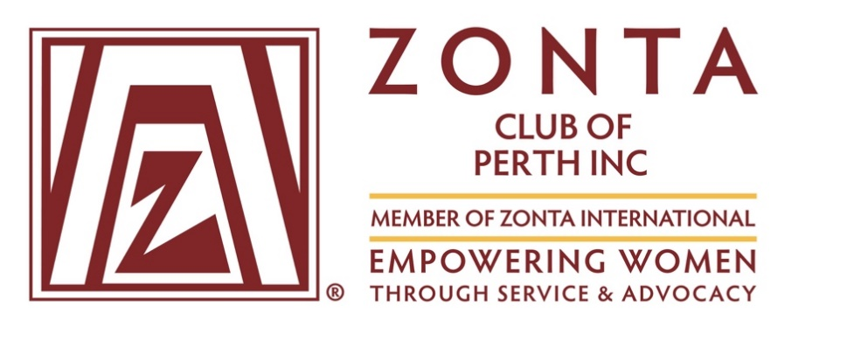
PO Box 237 Nedlands WA 6909
email: Secretary@zontaperth.org.au

Post-Secondary Education Award ($2000)
2025 Application Form

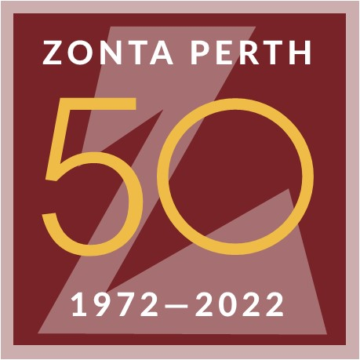

Zonta International is a leading global organization of professionals empowering women worldwide through service and advocacy.

The Zonta Club of Perth
Post-Secondary Education Award

The aim of the Award of $2000 is to encourage
a woman aged 25 years or over
to complete a Post-secondary Qualification at a recognised course in a Western Australian institution

ELIGIBILITY

A woman aged 25 years or over who is in need of financial assistance is eligible to apply, and who:

- Is able to demonstrate the need of financial assistance  - Is a woman aged 25 years or over as at 14 June 2025.  - Is an Australian citizen, or has permanent residency status | ☐  ☐  ☐
- Is residing in Western Australia for the 2025 academic year  - Is studying towards a post-secondary qualification (eg TAFE Certificate/Diploma, or University undergraduate degree. The award is not offered for those enrolled in a postgraduate qualification.  - Preference will be given to students who have not received a scholarship or financial award during the course of their current study program | ☐  ☐  ☐
- Has successfully completed at least all the first-year units/requirements of an undergraduate degree/or TAFE certificate/diploma qualification course (on a full or part time basis)  - Is able to provide 1 (one) written academic reference and 1 (one) written personal reference  - Can confirm their nationality, PR status  - Provides proof of Income Documents (Recent payslips, or Centrelink Statements with pension/allowance details)  - Provides their latest Academic Transcript/Record | ☐  ☐  ☐  ☐  ☐

Applications must be made on the attached form. The completed form and attachments must be sent by email to:

Secretary@zontaperth.org.au

Applications due: Friday 14 June 2025, 5pm AWST

SHORT LISTING AND INTERVIEW OF APPLICANTS

- All applications dealt with in confidence.
- Following the close of applications on Friday 14 June, 2025, successful candidates will be invited for an interview.
- Interviews will be held in late June 2025.
- The successful awardee will be invited for an awards ceremony to take place on Thurs 10 July 2025 at the Zonta Club of Perth to receive her award and to give a short address to the Club’s members.
- The decision of the panel will be final and binding and will be published on the Zonta Website following the awards ceremonies in July 2025.

For any queries, please email: Secretary@zontaperth.org.au
The Zonta Club of Perth
Post-secondary Education Award 2025

Application Form

Applicant details

Surname

Given name(s)

Date of birth

Address (during academic year)

Postal address

Telephone number | Mobile
Email

Are you an Australian Citizen or Permanent Resident? | Yes / No (Please circle response)
How long have you resided in Western Australia? | ……………………….Years
Number and ages of dependent
Children if any

Income Details
Please provide total WEEKLY income from all sources

 | Applicant’s weekly income | Partner’s Weekly Income
Salary / Wages (Include any commission)

Government Payments
(Combined payments from government pensions and benefits, including Family Allowance)
Maintenance and Child Support Received (contributing income from a parent NOT part of a joint custody arrangement)
Other forms of Income (Please specify)

TOTAL WEEKLY INCOME

Accommodation Expenditure

Please provide the weekly rent or mortgage expenditure for your home

Supporting Information

Applications for other Scholarships / Awards | Have you applied for any scholarship/s or other awards, whose outcome has not been determined, to assist in your study in 2025?  Yes □ No □  Please provide details, including value
Supporting Information continued

Education (current)

- University/TAFE
- Current enrolment (include Major)
- Year of course commencement
- Proposed completion date of qualification
- Attachment – required details | Attachment should confirm enrolment for 2025, subjects previously passed and subjects enrolled.
Academic prizes, awards, and other academic achievements

Past or present extra–curricular activities, hobbies, club, or organisation memberships (including any offices held), community involvement or other achievements that you consider are relevant.

Employment or work experience
(past and present)

Future professional goals

Please outline how this award will assist you in completing your studies

Please note
ALL QUESTIONS MUST BE ANSWERED FOR YOUR APPLICATION TO BE ELIGIBLE

Supporting Statement

Please provide any other information that you believe is relevant to this application. You may wish to detail any special circumstances that should be taken into consideration in assessing financial circumstances (attach separate sheet if more space is needed).

.......................................................................................................................................................................

…………………………………………………………………………………………………………………………..

…………………………………………………………………………………………………………………………..

…………………………………………………………………………………………………………………………..

…………………………………………………………………………………………………………………………..

…………………………………………………………………………………………………………………………..

……………………………………………………………………………………………………………………………

……………………………………………………………………………………………………………………………

……………………………………………………………………………………………………………………………

The information I have provided in this application is, to the best of my knowledge, true and accurate. Incorrect and or incomplete information relating to this application is my responsibility and may result in my application being deemed inadmissible and/or the withdrawal of any offer for award.

Signature ………………………………………………………………….Date…………………………………….

The following documents MUST accompany your Application

Copy of results of latest available tertiary examination results | If selected for interview please bring original documents
Copies of at least 2 (two) written references  1 (one) written academic reference and 1 (one) written personal reference | One professional and one personal reference.  Referees should confirm applicant’s eligibility and suitability to meet the requirements of the Award.  The references MUST include the name and address of the referee and their telephone contact number

The following documents MUST be supplied at Interview for confirmatory purposes

- Passport or other identity document
- Original Australian Citizenship or/Permanent Residency documents
- Proof of Income documents eg Centrelink, Child Support, Payslip etc
- Latest Academic record if received after submission of application
- Copy of recent pay/slips; if reliant on Government allowances, please provide a statement from Centrelink or the relevant pension / allowance agency

APPLICATIONS WILL NOT BE ELIGIBLE UNLESS ALL QUESTIONS ARE ANSWERED AND THE REQUESTED ATTACHMENTS ARE PROVIDED AS SPECIFIED

